JOIN US FOR OUR <month> STONE SOUP dinner
Hosted by <sponsors>

Where: <venue>
When: <date> Join us @ 3 pm to help prepare for the meal. Join us for dinner @ 5:00 – 6:30
Who: Everyone is welcome! Bring a friend. All ages!
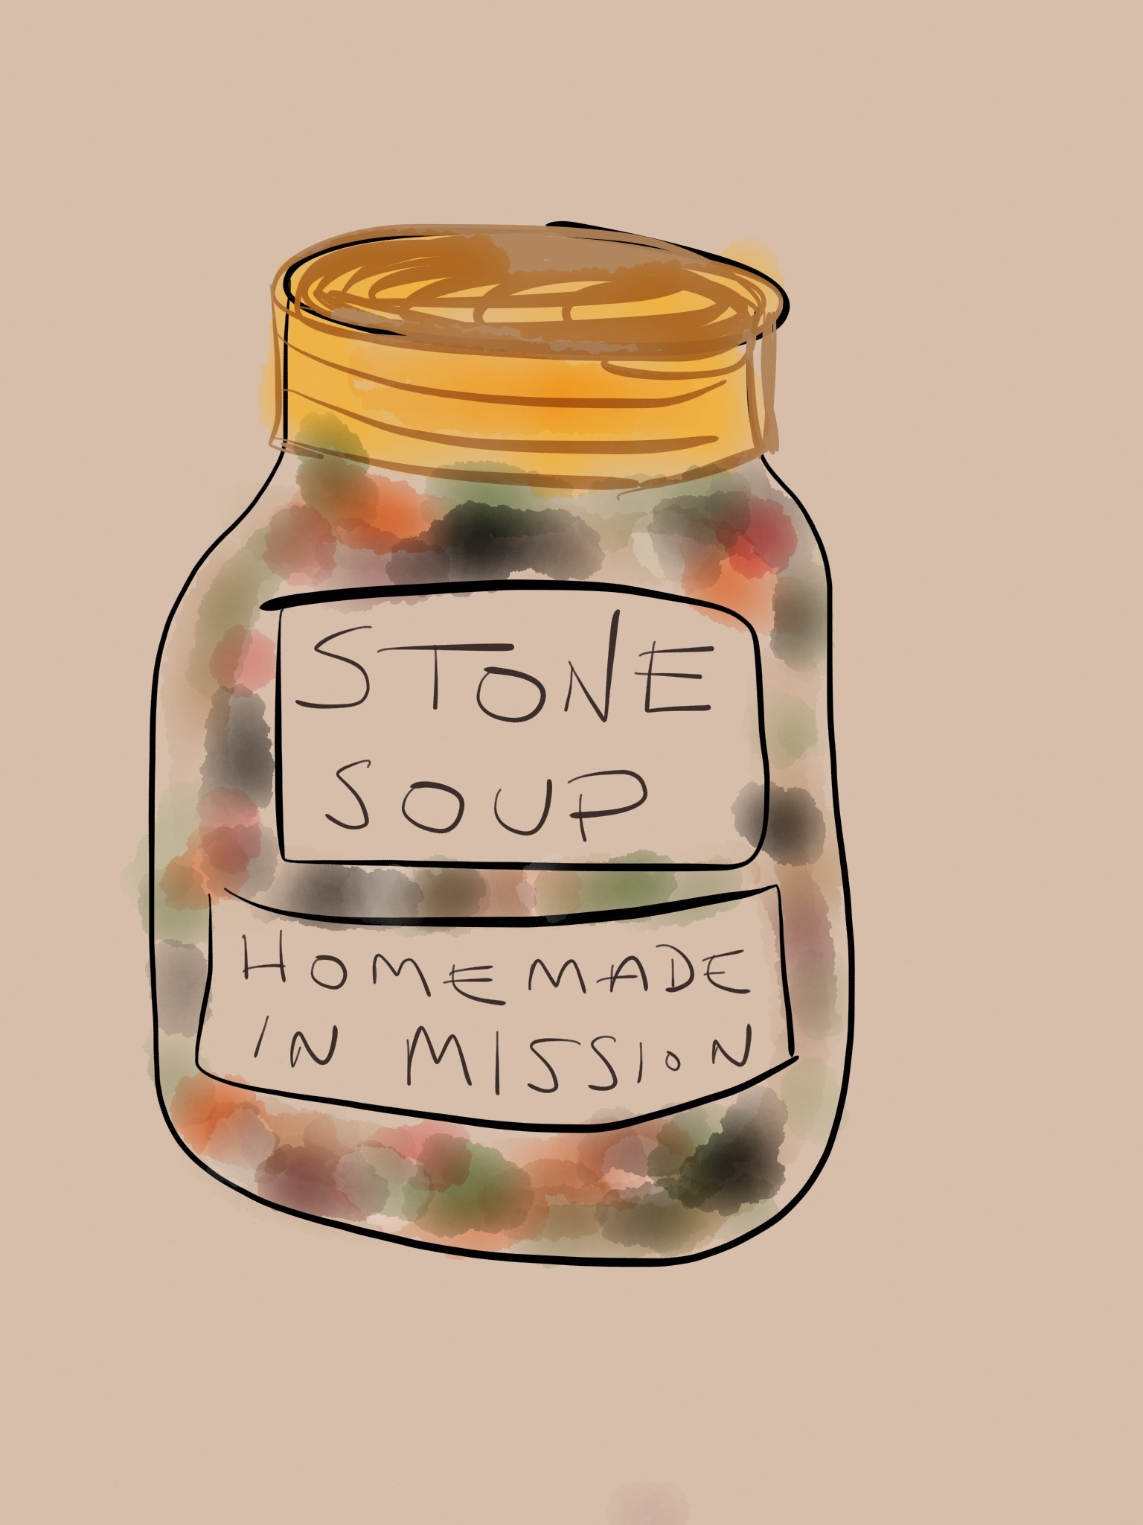
Why:
- Learn about Stone Soup.
- Share a FREE <dinner choices> dinner with neighbours.
- Share your story!
- Learn about <dinner topic; host info>

Please bring an item for the table, if you can afford to help. This month, we need <category of dinner ingredients>: <specific dinner ingredients needed>

We always need Ziploc containers & bags, canned goods, granola bars, cereal, bread, margarine, cookies, apples & oranges, toiletries, socks, baby items, laundry soap & feminine hygiene items. We want helping hands. Come learn more about Stone Soup and how you can help Mission tackle homelessness.

Spread the word!
Contact us at stonesoupmission@outlook.com to discuss how you can help!

